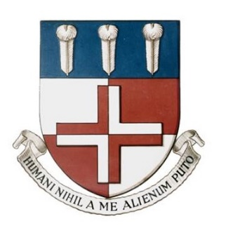
Royal London & Percivall Pott Teaching Timetable – Mar 2015
Basic Sciences
Time: Tuesdays 15:00-17:00
Venue: Education Academy, Royal London Hospital

Date | Topic | Speaker | Room
1st Mar | Upper limb biomechanics  Spine biomechanics | Mr Zulfi Sadiq  Mr Sherif Montgomery | Sem room 1
8th Mar | Audit |  | Sem room 6
15th Mar | How to pass the FRCS (I)  Bone biology (I) | Mr Syed Aftab  Mr Pete Bates | Sem room 1
22nd Mar | Embryology, genetics and skeletal dysplasias – VIVA session | Mr Manoj Ramachandran | Sem room 6
29th Mar | Cellular and molecular basis of wound healing  Shock, Metabolic and immunological response to trauma | Mr Aswin Vasireddy | Sem room 5
5th Apr | Neurophysiology and spinal cord monitoring  Biotribology | Mr Syed Aftab  Mr Sheraz Malik | Sem room 5
12th Apr | Surgical infection:  Antibiotics, theatre design, the immunocompromised patient | Alex Vris | Sem room 6
26th Apr | Materials and orthopaedic implants, MoM  Hip biomechanics  Foot & ankle biomechanics Junior doctors strike | Mr Sammy Hanna  Mr Paul Lee  Mr Lee Parker | Sem room 6
3rd May | Bone biology (II)  Knee biomechanics | Mr Pete Bates  Mr Sebastian Dawson-Bowling | Sem room 5
10th May | Audit |  | Sem room 6
17th May | Tissue biology – Collagen, joints and cartilage, tendons and ligaments | Mr Kash Akhtar | Sem room 6
24th May | Neurophysiology and spinal cord monitoring  Inflammatory arthropathies and peri-operative issues | Mr Syed Aftab  Prof Ali Jawad | Sem room 6
31st May | Legal and ethical aspects of orthopaedics  Muscle, NCS, EMGs | Mr Henry Frydenson MBE  Mr Steve Key | Sem room 6
7th June | Audit |  | Sem room 5
14th June | Pharmacology  Haemophilia, haemochromatosis, sickle cell  Orthopaedic antibiotic prophylaxis (10 mins) | Mr Daud Chou  Prof Gareth Scott  Dr Jayshree Dave | Sem room 4
21st June | Materials and orthopaedic implants, MoM  Hip biomechanics  Foot & ankle biomechanics | Mr Sammy Hanna  Mr Paul Lee  Mr Lee Parker | Sem room 4
28th June | Biotribology  Orthopaedic Oncology | Mr Sheraz Malik  Mr Rej Bhumbra | Sem room 4
5th July | Coagulation and anti-coagulation  Tissue biology – Collagen, joints and cartilage, tendons and ligaments | Mr Daud Chou  Mr Kash Akhtar | Sem room 5
12th July | Knee biomechanics (II)  Hoffmann 3 training | Prof Gareth Scott  Stryker (James Pritchett) | Sem room 5
19th July | Neurophysiology and spinal cord monitoring  Pharmacology | Mr Syed Aftab  Mr Daud Chou | Sem room 1
26th July | Materials and orthopaedic implants, MoM | Mr Sammy Hanna | Sem room 5
Summer break

